Chapter 7, Problem 79.

In the circuit in Fig. 7.143, the switch has been in position 1 for a long time but moves instantaneously to position 2 at t = 0. Determine i₀(t).

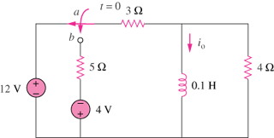

Figure 7.143
For Prob. 7.79.

